Chapter 6, Problem 13.

Find the voltage across the capacitors in the circuit of Fig. 6.49 under dc conditions.

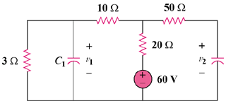
70 Ω

Figure 6.49
For Prob. 6.13.

